**Assignment – 6**

**1. Write a Java program using try and catch to generate Array Index Out of Bound Exception and Arithmetic Exception.**

import java.util.Scanner;

public class ArrayIndex {

public static void main(String[] args) {

Scanner scan = new Scanner(System.in);

System.out.println("Name : Gokul Sarkar \nRoll No : 46 ");

System.out.print("Enter The Length of Array:\t");

int n = scan.nextInt();

int[] arr = new int[n];

for (int i = 0; i <= n; i++) {

System.out.println("Variable " + (i+1) + " is:\t");

try {

arr[i] = scan.nextInt();

arr[i] = arr[i] / (n-i-1);

}

catch (ArrayIndexOutOfBoundsException e){

System.out.println("Array Index is Out of Bound.");

}

catch (ArithmeticException e){

System.out.println("This is an Arithmetic Exception.");

}

}

}

}

**Output:**

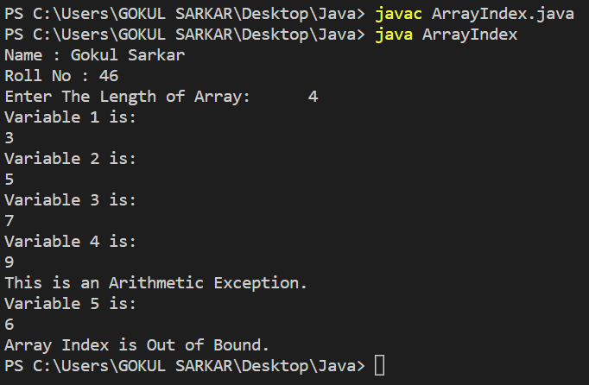

**2. Write a class that keeps a running total of all characters passed to it (one at a time) and throws an exception if it is passed a non-alphabetic character.**

import java.util.*;

class Counter{

static int count = 0;

int[] chars = {'A', 'Z', 'a', 'z'};

protected void pass(char x) throws Exception{

if (((int) x >= chars[0] && (int) x <= chars[1]) || ((int) x >= chars[2] && (int) x <= chars[3])) {

count++;

System.out.println("Total Character Number is:\t" + count);

}

else {

String msg = "\nNot a Character.\nTotal Number of Characters is:\t" + count;

throw new Exception(msg);

}

}

}

public class non_alphabetic {

public static void main(String[] args) {

Scanner scan = new Scanner(System.in);

Counter c = new Counter();

System.out.println("Name : Gokul Sarkar \nRoll No : 46 ");

System.out.println("How Many Times You Want to Pass Input:\t");

int n = scan.nextInt();

for (int i = 0; i < n; i++) {

System.out.println("Character Number " + (i + 1) + " is:\t");

try {

c.pass(scan.next().charAt(0));

}

catch (Exception e) {

System.out.println(e);

}

}

}

}

**Output:**

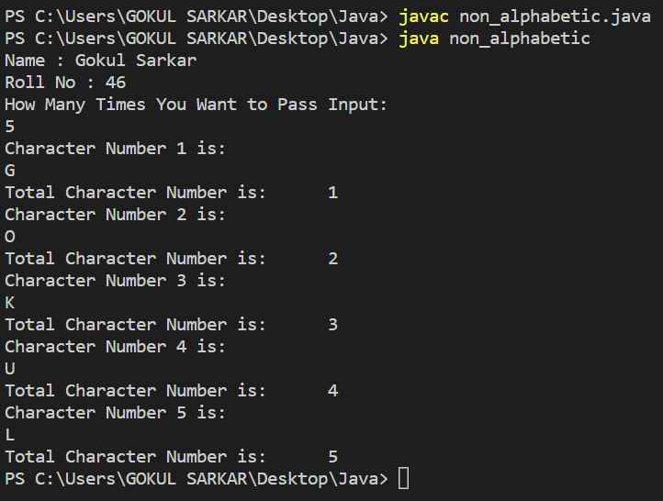

**3. Write a program that takes a value at the command line for which factorial is to be computed. The program must convert the string to its integer equivalent. There are three possible user input errors that can prevent the program from executing normally.**

**\* The first error is when the user provides no argument while executing the program and an ArrayIndexOutOfBoundsException is raised. You must write a catch block for this.**

**\* The second error is NumberFormatException that is raised in case the user provides a non-integer (float double) value at the command line.**

**\* The third error is IllegalArgumentException. This needs to be thrown manually if the value at the command line is 0.**

public class Question3 {

static int factorial(int x){

int fact = 1;

for (int i = 1; i <= x; i++) {

fact *= i;

}

return fact;

}

public static void main(String[] args) {

System.out.println("Name : Gokul Sarkar \nRoll No : 46 ");

try{

if (args[0].equals("0"))

throw new IllegalArgumentException("0 is not Allowed.");

System.out.println(factorial(Integer.parseInt(args[0])));

}

catch (ArrayIndexOutOfBoundsException e){

System.out.println("Array Index Out of Bound.");

}

catch (NumberFormatException e){

System.out.println("Value is Not an Integer.");

}

catch (IllegalArgumentException e){

System.out.println(e);

}

}

}

**Output:**

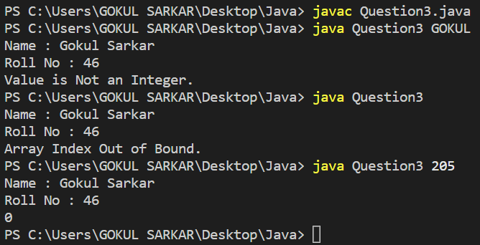

**4. Create a user-defined exception named CheckArgument to check the number of arguments passed through the command line. If the number of arguments is less than 5, throw the CheckArgumentexception, else print the addition of all the five numbers.**

class CheckArgument extends Exception{

public CheckArgument(String s){

super(s);

}

}

public class Question4 {

public static void main(String[] args) {

System.out.println("Name : Gokul Sarkar \nRoll No : 46 ");

try {

if (args.length < 5)

throw new CheckArgument("Argument Number is Less than 5.");

else {

int x = 0;

for (String c : args) {

x += Integer.parseInt(c);

}

System.out.println("The Sum is:\t" + x);

}

}

catch (CheckArgument e){

System.out.println(e);

}

}

}

**Output:**

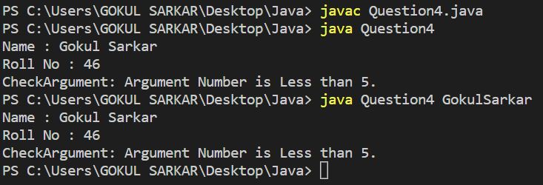

**5. Write a java program to create a custom Exception that would handle at least 2 kinds of Arithmetic Exceptions while calculating a given equation (e.g. X+Y*(P/Q)Z-I).**

import java.util.Scanner;

class CustomException extends Exception{

public CustomException(String s){

super(s);

}

}

public class Question5 {

public static void main(String[] args) {

Scanner scan = new Scanner(System.in);

int x, y, p , q, z, i;

System.out.println("Name : Gokul Sarkar \nRoll No : 46 ");

System.out.print("Value of X = ");

x = scan.nextInt();

System.out.print("Value of Y = ");

y = scan.nextInt();

System.out.print("Value of P = ");

p = scan.nextInt();

System.out.print("Value of Q = ");

q = scan.nextInt();

System.out.print("Value of Z = ");

z = scan.nextInt();

System.out.print("Value of I = ");

i = scan.nextInt();

try {

if (q == 0)

throw new CustomException("Divide By Zero is not Allowed.");

else

System.out.println("The Result is:\t" + (x + y * (p / q) * z - i));

}

catch (CustomException e){

System.out.println(e);

}

}

}

**Output:**

